A minor Project Proposal Report on

**HOTEL RESERVATION SYSTEM**

Submitted in Partial Fulfillment of the Requirements for the Degree of

**Bachelors of Engineering in Computer Engineering**

Under Pokhara University

Submitted by:

Keshav raj Poudel(171346)

Khom Raj Thapa Magar(171347)

DhirajChaudhary(171311)

Under the Supervision of:

**Dr. Roshan Chitrakar**

Date:

SEPT 15, 2019

**Department of Computer Engineering**

**Nepal College of**

**Information Technology**

(Affiliated To Pokhara University)

(Affiliated to Pokhara University)

Balkumari, Lalitpur, Nepal.



# ABSTRACT

“HOTEL RESERVATION SYSTEM” is a computerized system that provides an electronic platform to hotel lakeside Pokharafor performing the operations of hotel room reservations.

We know that users want a simple to use, effective in house Windows-based application to automate their day-to-day hotel management activities. The manual process of booking hotel rooms for clients is extremely tedious. Keeping track of large customer bases and their personal details is complicated and time consuming since writing and managing paper work is required.

Our booking system is an easy to use the hotel booking system product that automates day-to-day hotel management through an online booking system. This software application will help admin to handle the customer information, room allocation details, payment details, billing information, etc.

The hotel reservation system designed in this project was developed using the PHP as a Server site scripting and MYSQL as its database. The completed project delivers a system that enables the receptionist to record details of the customer, search for unoccupied rooms as per requirements and reserve suitable rooms

**Key Words:** Reservation, Search, Record, PHP, MYSQL

Table of Contents

ABSTRACT i

LIST OF FIGURES iii

LIST OF TABLES iv

1 INTRODUCTION 1

1.1 Background 1

1.2 Problem Statement 2

1.3 Objectives 2

1.4 Project Features 2

1.5 Feasibility Analysis 3

1.5.1 Economic Feasibility 3

1.5.2 Technical Feasibility 3

1.5.3 Operational Feasibility 4

1.5.4 Legal Feasibility 4

2 LITERATURE REVIEW 4

3 METHODOLOGY 6

3.1 Introduction 6

3.2 Hardware and software requirement 7

3.2.1 Hardware Requirement 7

3.2.2 Software requirement 7

3.3 Proposed system analysis 7

3.4 Proposed system design 8

3.5 Proposed project block diagram 8

3.6 Working principle 8

4 RESULTS AND ANALYSIS 9

4.1 Expected Output 9

4.2 Budget Analysis 9

4.3 Work Schedule 9

5 CONCLUSION 9

REFERENCES 10

# LIST OF FIGURES

**FIGURE PAGE**

Figure 1.1: -------------------------------------------------------------------------- 2

Figure 1.2: --------------------------------------------------------------------------- 3

Figure 2.1: --------------------------------------------------------------------------- 7

# LIST OF TABLES

**TABLE PAGE**

Table 1.1: ---------------------------------------------------------------------------- 2

Table 1.2: ---------------------------------------------------------------------------- 3

Table 2.1: ---------------------------------------------------------------------------- 7

# INTRODUCTION

The hotel reservation system is a system that we want to implement at hotel lakeside in pokhara in order to overcome the situation that now hotels are facing of using manual.Also hotel Lakeside is not popular in Pokhara due to lack of information, we can be using the web-based to advertise it a place for meditation and relax. But when we apply this system, some of the information will be easier to be known with outsider people and can be easier to reach due to the web system. As the current system is a file based one, management of the hotel has to put much effort on *securing those files. They can be easily get damaged by a fire,insects or even by a natural disaster like tsunami. Keeping files takes much times and wastes much precious man hours. Although we can’t trust the accuracy of calculations done by manually, it’s not a surprise of encountering problems. /* If we want to check for a previous room record or a reservation detail, management will be in great problem. It’s a tough and time taking process to search for a record in a file. It manages all these problems properly.

## Background

Online reservation system is a popular method for booking hotel rooms .travelers can book rooms on a computer by using online security to protect their privacy and financial information. Online hotel reservations are also helpful for making last minute travel arrangements. Prior to the **Internet,** travelers could write, telephone the hotel directly, or use a travel agent to make a reservation. Nowadays, online travel agents have pictures of hotels and rooms, information on prices and deals, and even information on local resorts.

An online hotel reservation system can also be regarded as a central reservation system which is a computerized system that stores and distributes information of a hotel, resort or other lodging facilities.

The Hotel Lakeside is walk-up hotel which aims to provide the futuristic design, modern style and romantic energy at very comfortable rates. This project has GUI based software that will help in storing, updating and retrieving the information through various user-friendly menu driven modules.

## Problem Statement

Based on the research conducted, the proponent’s found out the problem of this study is: how will this system will help the management and the staff to have an accurate service at the same time to monitor the record of the customers.

**General Problem:**

The Hotel Lakeside only has the manual reservation system. So, the proponents proposed a computerized hotel reservation.

**Specific Problem:**

1. Due to low in security inside the room, possible loss of records and retrieving files may occur.
2. Due to the manual recording of reserving a room, difficulty in searching of finding the records may occur.
3. Low process of transaction may take place, as it gives the customer or the client to take more time in reserving a room because of manual processing.

## Objectives

* To avoid the Manual and Repetitive work.
* Real Time information of availability of rooms.
* To provide a website that can allow a user to search and reserve a hotel room or cancel his/her reservation over the internet at any time.
* Improving decision making.

## Project Features

* Long term storage of records
* High accuracy in calculation.
* Efficiency in modification, sorting and retrieval of data.
* Inexpensive updating in facilities and terms of organizations.

## Feasibility Analysis

The objective of feasibility study is to determine whether or not the proposed system is feasible. The feasibility is determined in terms of three aspects. They are:

### Economic Feasibility

As a part of this, the costs and benefits associated with the proposal system are compared and the project is economically feasible only of tangible and intangible benefits outweigh the cost. The cost for hotel reservation system is outweighing the cost and efforts involved in managing the registers, books, files and generation of various reports. The system also reduces the administrative and technical staff to do various jobs that single software can do. So, this system is economically feasible.

### Technical Feasibility

The assessment is based on an outline design of system requirement in term of input, processer, output, field, programs and producers. This can be qualified in term of volumes of data, trends, frequency of updating etc. in order to estimate whether the new system will perform adequately or not. Technological feasibility is carried our to determine whether the company has the capacity, in term of the projects when writing a feasibility report, the following should be taken to consideration.

* A brief description of the business
* The part of business being examined
* The human and economic factor
* The possible solution to the problem

### Operational Feasibility

The user must know about the operation of software product to use it in the efficient way. Thus, the process of operation must be pre-defined in many ways. Such as training, meeting, presentation demo etc. Since the system is being in user friendly way, the new students/employee within a time can master it and use it easily. We can give training to the customers if there is some difficulty for customer in using it.

### Legal Feasibility

Legal feasibility determines whether the proposed system conflict with the legal requirements e.g. the data protection act. It will be done by some legal advisors.

# LITERATURE REVIEW

Hotel Reservation System development using the PHP program has lots of codes, using Internet in gathering information partially contributed to the success of this project. Since, PHP is an open source program, development of Hotel Reservation System was not too difficult.. However, thanks to the cyber world (Internet) that makes it possible to study and make comparison in needs of some code function.

The application of the internet in the business world has become a major trend in practice and generated a hot stream of research in the recent literature. The internet, as a collection of interconnected computer networks provides the free in exchanging of information. As such, the internet has been becoming a powerful channel for business marketing and communication, and for new business opportunities - as it is often called as “e-business” or “e-commerce” today. It provides the communication between the consumers and companies and through electronic data interchange, buyers and sellers can exchange standard business transactions such as invoices or purchase orders with remarkable ease.

The hotel industry is certainly full aware of this trend and fully willing to contribute its share in this effort. Online system has evolved to be a cornerstone in support of computer software user of all kinds. It is an electronic interactive system that delivers information to users via telephone lines to personal computer (PCs) or via cables to terminals.

Among other web site that was used in my research is freesourcecode.com. It provided us with different codes which we used in the development of this project.

Using of textbooks and journal on the net was also a great source of information and assistance in realizing the goal of this project. For instance, "A review of PHP compilers and their outputs" Favre, Nicolas (2010-02-16) gave a good layout of product design. Also, Personal Home Page Tools (PHP Tools) Leadoff, Rasmus (1995-06-08), was very helpful and supportive in the product development of the pages of this project.

# METHODOLOGY

## Introduction

A methodology is a development system of methods that is used to plan, structure and control the process of developing an information system. A wide variety of published development methodologies have evolved over the years, each with its own recognized strength and weakness. Different types of system project use available methodologies that best suits a specific project based on the project’s various technical development process. Below are the types of methodologies applied in developing this project.

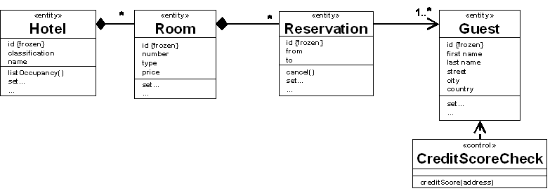

And the methodology adopted for this research work is object-oriented methodology (OOM). We live in a world of objects. These objects exist in nature, in man-made entities, in business, and in the products that we use. They can be categorized, described, organized, combined, manipulated and created. Therefore, an object-oriented view has come into picture for creation of computer software. This methodology asks the analyst to determine what the objects of the system are, how they behave over time or in response to events, and what responsibilities and relationships an object has to other objects. OOM of building systems takes the objects as the basis. Firstly, the system to be developed is observed and analyzed and the requirements are defined. Secondly, the objects in the required system are identified e.g. customers, admin, computer systems etc. in simple terms, OOM is based on identifying the objects in a system and their interrelationships.

## Hardware and software requirement

### Hardware Requirement

* Computer
* Internet
* Mouse
* Keyboard
* Minimum 128 RAM
* Minimum 500 MB hard disk

### Software requirement

The software is the non-physical part of the system that uses the hardware components to successfully run the system that has been built. The system must have word processor. The system will run windows Operating System .

Operating system: Windows, Linux

Different software we used are:

Language : PHP

Database :MYSQL

## Proposed system analysis

Systems analysis is a process of collecting factual data, understanding the processes involved, identifying problems and recommending feasible suggestions for improving the functionality of the system. This involves studying the business processes, entity relationships gathering operational data, understand the information flow, finding out bottlenecks and evolving solutions for overcoming the weaknesses of the system to achieve the organizational goals. System Analysis also includes decoupling of complex processes that make up the entire system, identification of data store and manual processes.

## Proposed system design

## Proposed project block diagram

## Working principle

Algorithm:

Step1: START

Step2: Go to Home

Step3: Do you have a account?

3.1: If yes, Login to account

3.1.1: Is there is a single room vacant?

3.1.1.1: If yes, See the room and make payment

3.1.1.2: If No, Is other room available?

3.1.1.2.1: If yes, See the room and make payment

3.1.1.2.2: No, exit

3.2: If no, register for the account and go to step 3

Step4: STOP

# RESULTS AND ANALYSIS

## Expected Output

* All the detail related to customer could be found in one place like the hotel/room booking details, fees details, message detail, customer detail etc.
* The same system could be us be used by both the account section and the hostel management for their specific needs and purposes.
* The home page of our project is:

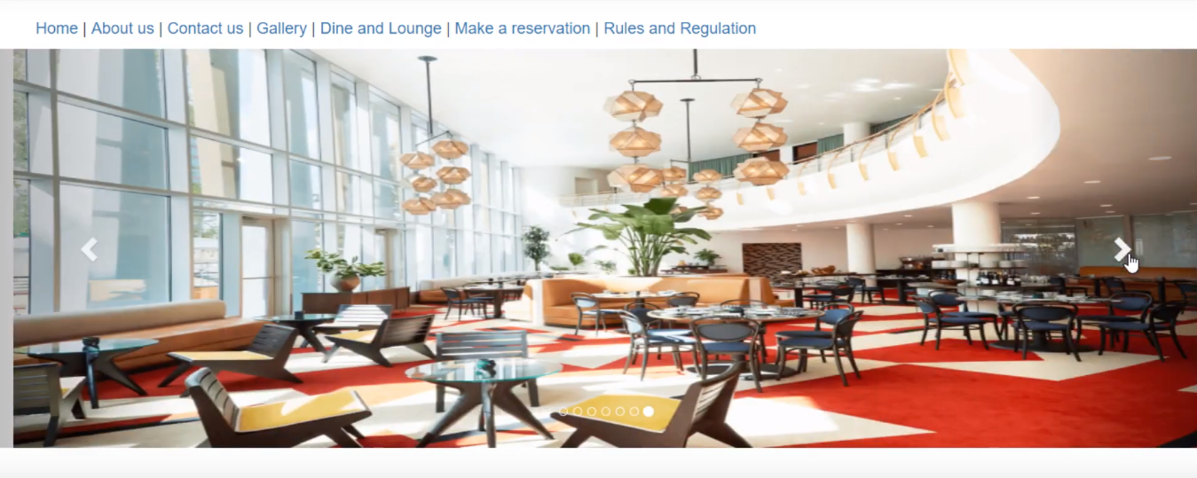

## Budget Analysis

|  |  |  |
| --- | --- | --- |
| S. N | PARTICULARS | QUANTITY |
| 1. | Hourly cost per programmer | Rs 500 |
| 2. | No. of hours per day | 3 hours |
| 3. | No. of working day per weeks | 4 days |
| 4. | Project Period | 3 months |
| 5. | No. of programmer | 4 |
| 6. | Total programmer cost | Rs 50,000 |
| 7. | Total project cost | Rs 50,000 |

## Work Schedule

# CONCLUSION

Based on the finding of the study, the following conclusion weredrawn within the limitation and scope defined in the study.

* The Online Hotel Reservation System was developed for the hotel Lakesideto replace the manual process of booking for a hotel Room or any other facility of the hotel.
* The old system does not serve the customer in a better way; rather it makes customer data vulnerable.
* The new system keeps proper records of customers for emergency and security purposes. The hotel’s advertising effort is now accompanied by a virtual tour created on the system.

# REFERENCES

[1] M. Naor and A. Shamir, "Visual cryptography",*Eurocrypt*1994, *Lecture Notes in Computer Science*, vol.950, pp. 1-12, Springer-Verlag, 1994

[2] Z. Zhou, G. R. Arce and G. Di Crescenzo,  "Halftone visualcryptography",  *IEEE Trans. Image Process.*,  vol. 15,  no. 8,  pp.2441-2453, 2006

[3] Z.M.Wang, G. R. Arce, and G. Di Crescenzo, “Halftone visual cryptography via direct binary search”, Proc. EUSIPCO’06, Florence, Italy, Sep. 2006

[4] T. M. Alkharobi, A. K.Alvi, “New Algorithm For Halftone Image Visual Cryptography”, *IEEE 2004*

[5] Y.-C.Hou, “Visual cryptography for color images”, *Pattern Recognition*, vol. 36,iss. 7, pp. 1619–1629, 2003

[6]M. Nakajima and Y. Yamaguchi, “Extended visual cryptography for natural images,” *Proc. WSCG Conf. 2002*, pp. 303–412, 2002

[7] Y.-C. Zeng and C.-H. Tsai "Controllable transparency image sharing scheme for grayscale and color images with unexpanded size",*Signal and Information Processing Association Annual Summit and Conference (APSIPA), 2013 Asia-Pacif*, pp. 1-4, 2013